POWER PRESS SAFEGUARDING

PART 24. MECHANICAL POWER PRESSES

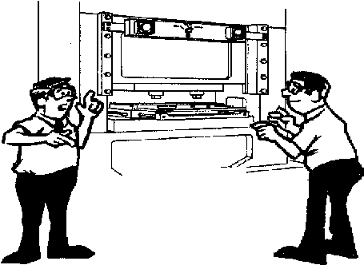
R 408.12411. Employer responsibilities.
Rule 2411.
(1) An employer shall train and instruct an operator in the safe method of work before starting work on any operation covered by this part. The employer shall ensure that correct operating procedures are being followed, that all required safeguards are installed, and that the safeguards are functional and are being used.

Training
Even the most elaborate safeguarding system cannot offer effective protection unless the worker knows how to use it and why. Specific and detailed training is therefore a crucial part of any effort to provide safeguarding against machine related hazards.
Thorough operator training should involve instruction or hands-on training in the following:
(1 a description and identification of the hazards associated with particular machines;
(2) the safeguards themselves, how they provide protection, and the hazards for which they are intended;
(3) how to use the safeguards and why;
(4) how and under what circumstances safeguards can be removed, and by whom (in most cases, repair or maintenance personnel only); and
(5) What to do (i.e., contact the supervisor) if a safeguard is damaged, missing, or unable to provide adequate protection.
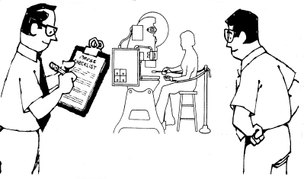
This kind of safety training is necessary for
new operators and maintenance or setup
personnel, when any new or altered safeguards
are put in service, or when workers are assigned
to a new machine or operation.
Inspection and Maintenance and Records

Machinery Maintenance and Repair
The employer shall establish and follow a program of periodic and regular
Inspections of his presses to insure that all their parts, auxiliary equipment, and safeguards are in a safe operating condition and adjustment. The employer shall maintain records of these inspections and the maintenance work performed.

Good maintenance and repair procedures can contribute significantly to the safety of the maintenance crew as well as to that of machine operators. But the variety and complexity of machines to be serviced, the hazards associated with their power sources, the special dangers that may be present during machine breakdown, and the severe time constraints often placed on maintenance personnel all make safe maintenance and repair work difficult.

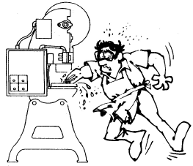
Training and aptitude of people assigned to these jobs should make them alert for the intermittent electrical failure, the worn part, the inappropriate noise, the cracks or other signs that warn of impending breakage or that a safeguard has been damaged, altered, or removed. By observing machine operators at their tasks and listening to their comments, maintenance personnel may learn where potential trouble spots are and give them early attention before they develop into sources of accidents and injury. Sometimes all that is needed to keep things running smoothly and safely is machine lubrication or adjustment. Any damage observed or suspected should be reported to the supervisor; if the condition impairs safe operation, the machine should be taken out of service for repair. Safeguards that are missing, altered, or damaged also should be reported so appropriate action can be taken to insure against worker injury.

Foot Pedals.
(1) The pedal mechanism shall be protected to prevent unintended operation from falling or moving objects, or by accidental stepping onto the pedal.
(2) A pad with a nonslip contact area shall be firmly attached to the pedal.
(3) The pedal return spring shall be of the compression type, operating on a rod or guided within a hole or tube, or designed to prevent interleaving of spring coils in event of breakage.
(4) If pedal counterweights are provided, the path of the travel of the weight shall be enclosed.
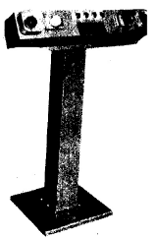

(7) The 2-hand control device shall protect the operator as prescribed in subrule (1)(d) of this rule. All of the following provisions apply to a 2-hand control device:

(a) When used in press operations requiring more than 1 operator, separate 2-hand controls shall be provided for each operator and shall be designed to require concurrent applications of all operators’ controls to activate the slide. The removal of a hand from any control button shall cause the slide to stop.
(b) Each 2-hand control that is used as a point of operation device shall be operated in the single-stroke mode only.
(c) When hand-in-die loading or unloading is used, the safety distance (Ds) between each 2-hand control device and the point of operation shall be greater than the distance determined by the formula prescribed in subrule (3)(e) of this rule.
(d) The position of the 2-hand controls shall be established and fixed in accordance with the provisions of subrule (1)(d) of this rule or subdivision (c) of this subrule, whichever shall apply. Only the supervisor or safety engineer may authorize relocating the controls.

Diesetting
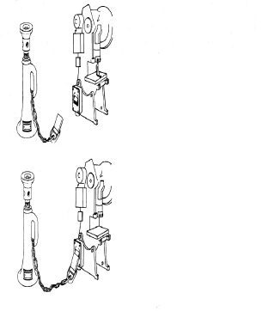
(4) The employer shall provide and enforce the use of safety blocks for use whenever dies are being adjusted or repaired in the press. Means shall be provided to prevent cycling a press with the safety block in place between the upper and lower dies, or between the bolster plate and slide face.

Safety Block--Power Press

A block which is inserted under the ram of power presses to permit the operator to change or adjust dies and make new setups. Prevents the ram from accidentally descending while operator is working in the danger zone. Available in various shapes and sizes and may have a power cut off feature when placed in position.

Block in Storage
Electric Safety Plug is
Connected. Control Circuit
is made and Press Can be Operated
Block
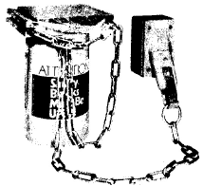
Safety Plug is Disconnected,
Press is inoperable

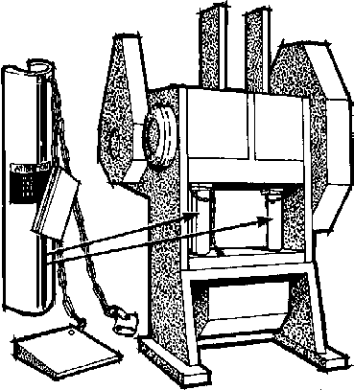

WHAT ARE AIR COUNTERBALANCES?
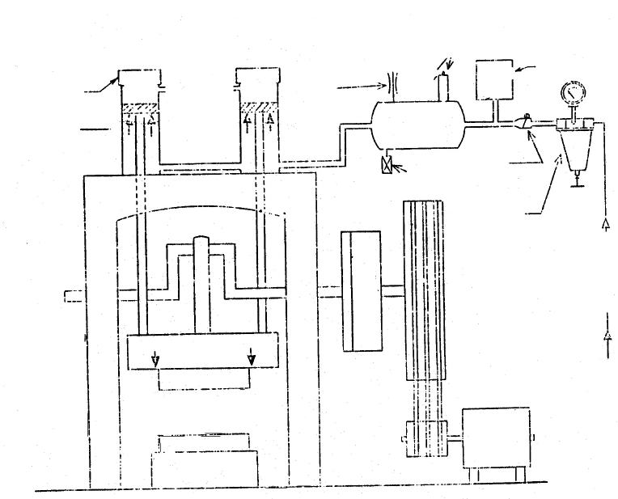
Filtered
Inlet Air
Relief Valve
Rule 2462
Press Switch
Check
Valve
Rule 2425(3)(c)
MOTOR
REGULATOR

Rule 2425(3)(b)
FLYWHEEL
AIR TANK
Air-operated
clutch & brake
Pitman
DRAIN
Plug
BED
RAM
PRESS
Counterbalance
Cylinders
Rule 2425(3)(a)
Air counterbalances are devices that support the weight of slide, connection, and upper die so that it is not suspended from the crankshaft bearings. Any geared press with long stroke (regardless of size), and any press with flanged slide for large, heavy dies, can benefit significantly from air counterbalancing.

HOW THEY WORK
Air counterbalances usually consist of one or two frame mounted air cylinders with pistons connected by rods to the slide. Air pressure is adjustable to support the combined weight of the slide, connection, and various size dies. The effect of counterbalancing the reciprocating mass is to put all clearances on the “up” side of the assembly.

WHY COUNTERBALANCES ARE USED
Counterbalancing the slide prevents sudden shifting of clearances when the slide contacts the work. Weight is taken off the main bearings and the slide runs more freely. Bearing wear is significantly reduced and gear performance is improved, since the teeth of the gear float when the weight of the slide is removed from the drive train. The ‘inch’ function and slide adjustment are both made easier. Set up is also facilitated.

Slide counterbalance systems.
(1) Spring counterbalance systems, when used, shall incorporate means to retain system parts in event of breakage.
(2) Spring counterbalances, when used, shall have the capability to hold the slide and its attachments at midstroke, without brake applied.
(3) An air counterbalance cylinder shall:
(a) Incorporate means to retain the piston and rod in case of breakage or loosening;
(b) Have adequate capability to hold the slide and its attachments at any point in stroke, without brake applied;
- Incorporate means to prevent failure of capability (sudden loss of pressure) in event of air supply failure.

